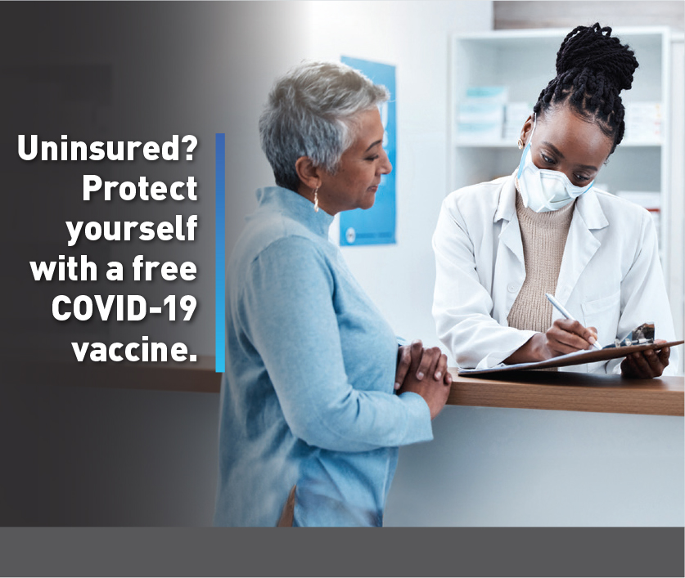 | 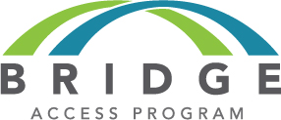  If you are 18 years or older and uninsured, or your health insurance plan doesn’t fully cover COVID-19 vaccination, you can get a free COVID-19 vaccine through the Bridge Access Program. Join us at Click or tap here to enter text. (e.g., Bridge Access Program vaccine clinic or health fair/event) to Click or tap here to enter text. (e.g., learn more and get vaccinated!)]  Date Click or tap here to enter text.  Time Click or tap here to enter text.  Location Click or tap here to enter text.
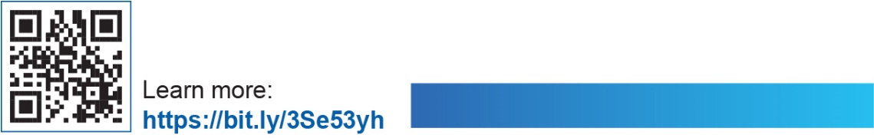 |  | 

If you are 18 years or older and uninsured, or your health insurance plan doesn’t fully cover COVID-19 vaccination, you can get a free COVID-19 vaccine through the Bridge Access Program. Join us at Click or tap here to enter text. (e.g., Bridge Access Program vaccine clinic or health fair/event) to Click or tap here to enter text. (e.g., learn more and get vaccinated!)
Date Click or tap here to enter text.
Time Click or tap here to enter text.
Location Click or tap here to enter text.


